Project Testing

The testing methodology for this project centered around unit testing in both Python and C for each function and submodule. In addition to the respective files to test each aspect, the makefile for this project contains a “test” rule that runs both test programs and outputs the results. At the submission of v3.0, make test returns the following (cropped for legibility):

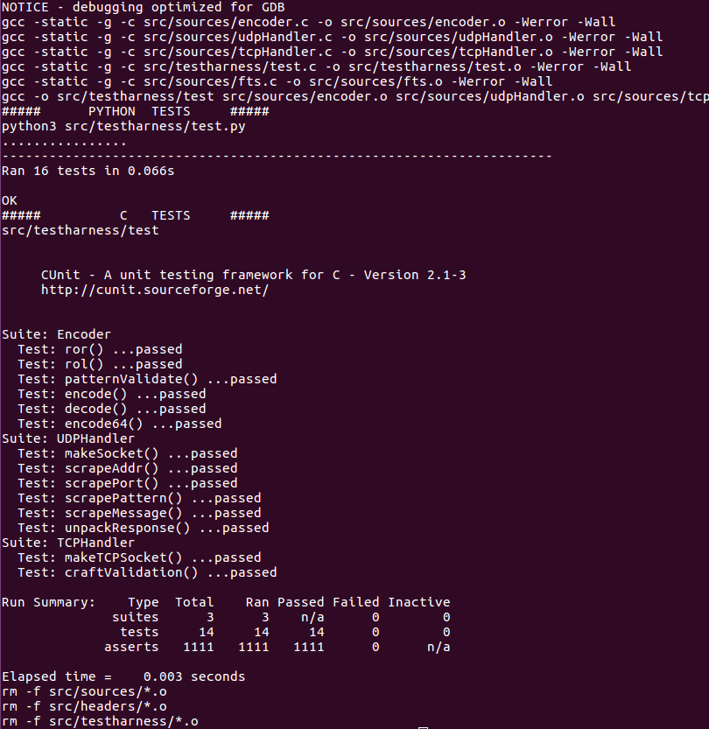
The Python testing process uses the Python UnitTest module. Each function is granted its own test case class containing a single function. That function contains a number of assert statements that compare the output of the function being tested to output computed by hand. For example, the following screen shot contains the test class for the encode function within the encoder module.

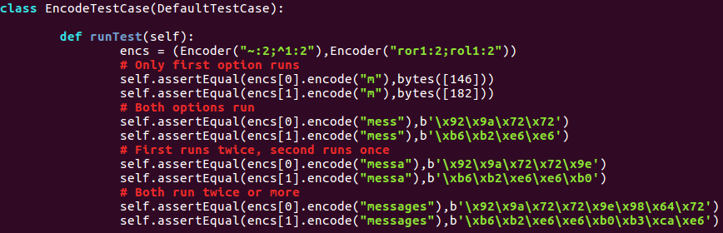
When run, the program will evaluate each assert statement and compare the input. If the comparison is successful, for example if in an assertEqual statement both inputs are equal, then the statement evaluates to true and execution continues through the remaining assert statements and tests. If a test fails, it would output something similar to the following:

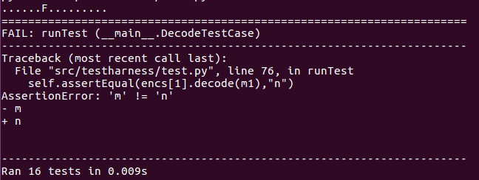
The output details the specific assert statement and test case class that failed, as well as some additional information based on the assertion to help correct the error.

Similar to the Python process, the C testing process uses the Cunit library. Within Cunit, test functions use assert statements validate the operation of the function being tested. However, Cunit tests are are divided into test suites with independent set up and tear down functions, and their assert statements only evaluate conditional statements. For example, the following screen shot details the test function for the encode function within the encoder module.

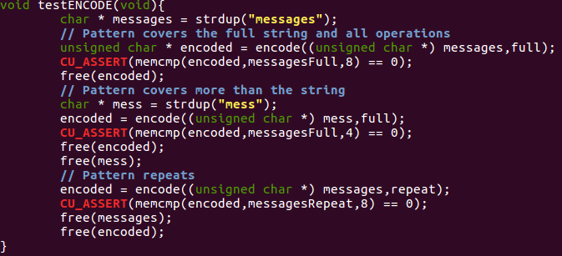
When run, the program will build the test suites for each submodule, add the test functions to each suite, then execute the suite beginning with the suite’s initialization function and ending with it’s clean up function. However the conditional within the CU_ASSERT statement evaluates, it is either marked as passed or failed and execution continues. If the assert statement failed, it is output to the console as shown below.
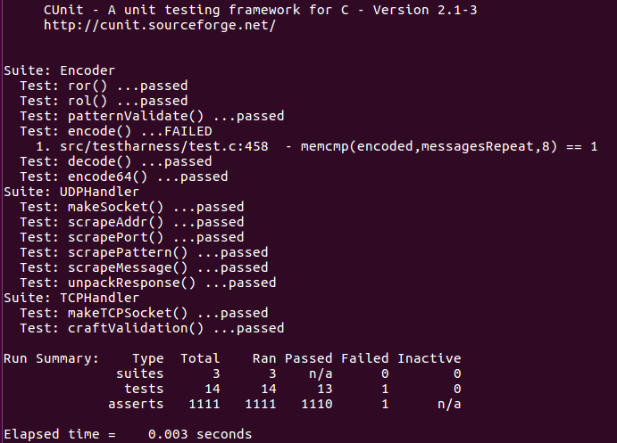
The output details the line number of the assert and the conditional provided to the assert statement. Contrary to the Python module, Cunit does not provide very verbose output on the failed conditional, however, it does allow for the execution of print statements within each test to provide more verbose output. Adding a print statement to just before the failed assert to display the two values in the call to memcmp aids significantly in debugging the function, as shown below.

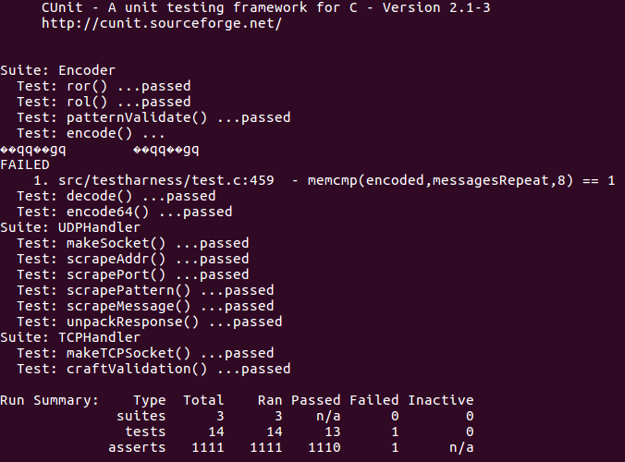
While the testing process for each module of the File Transfer Service is well established, I was not able to create an automated means of testing the three modules together. However, the python encoder module contains a main function that encodes /etc/passwd with the pattern “~:2;~:2” and sends the encoded output to stdout, which when redirected to a file enables use with diff to compare the encoded /etc/passwd with a file on the FSS. Without the script, my manual testing included running each program with verbose options, utilizing print statements throughout the FTS to ensure a failed transfer is immediately reported to the console, and wireshark to verify that each packet was sent as expected. Lastly, to simplify the process of typing in the commands, I would test with /etc/passwd and the encoding pattern “~:2;~:2” using the default entry in IPAddWhiteList for the FSS listening on 127.0.0.1:65535.

